Project Design Phase
Problem – Solution Fit Template

Date | 7 November 2025
Team ID | NM2025TMID09184
Project Name | Laptop Request Catalog Item
Maximum Marks | 2 Marks

Problem – Solution Fit Template:
The Problem–Solution Fit defines how effectively the Laptop Request Catalog Item project in ServiceNow addresses the challenges faced by employees and IT administrators during the laptop procurement process.
It ensures that the developed solution directly resolves issues such as manual request handling, data inconsistency, approval delays, and limited process transparency in hardware management workflows.
Purpose
- Solve Real Employee Challenges
Replace the outdated, email-based laptop request process with an automated and interactive Service Catalog item that minimizes effort and confusion.
- Enhance Operational Efficiency
Implement Catalog UI Policies and UI Actions to dynamically control field visibility and validation, ensuring faster and more accurate data entry.
- Improve Communication and Transparency
Enable automated notifications and status tracking for employees and IT staff to keep all stakeholders informed about request progress and approvals.
- Ensure Workflow Accuracy and Compliance
Track all configuration and workflow changes using update sets, ensuring compliance, traceability, and consistency across ServiceNow instances.
- Promote Scalability and Continuous Improvement
Establish a reusable, cloud-based request model that supports future hardware or accessory requests without additional manual setup.
Template:

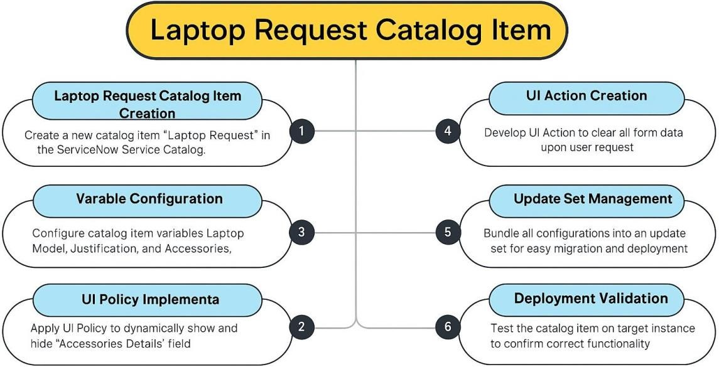

The project “Laptop Request Catalog Item” focuses on automating and streamlining the process of requesting laptops within the organization using ServiceNow’s Service Catalog module.
Previously, employees relied on manual or email-based submissions, which often led to missing information, delayed approvals, and untracked requests.
To address these challenges, the project introduces a dynamic catalog form where users can provide all required details — such as Laptop Model, Justification, Additional Accessories, and Accessories Details — in a structured format.
The form intelligently adapts to user inputs through UI Policies, making fields visible or mandatory when needed. Additionally, client-side UI Actions such as a “Reset Form” button improve usability and reduce submission errors.
This implementation ensures:
- Accurate and complete data capture for every request.
- Transparent approval workflows through ServiceNow.
- Enhanced governance and migration control via update sets.
- Improved end-user experience with dynamic and interactive forms.
Overall, the Laptop Request Catalog Item solution bridges the gap between employee needs and IT service efficiency, delivering a smart, scalable, and user-centric system for managing hardware requests effective

